ASSIGNMENT 6 - PYTHON OOP & FILE HANDLING
Name: MOHAMMED ADNAN
Roll No: 2503B05107

TASK 1
Explanation:
Student class creation & object printing.
Code:
class Student:
def __init__(self,name,roll,dept):
self.name=name; self.roll=roll; self.dept=dept
Output Screenshot:
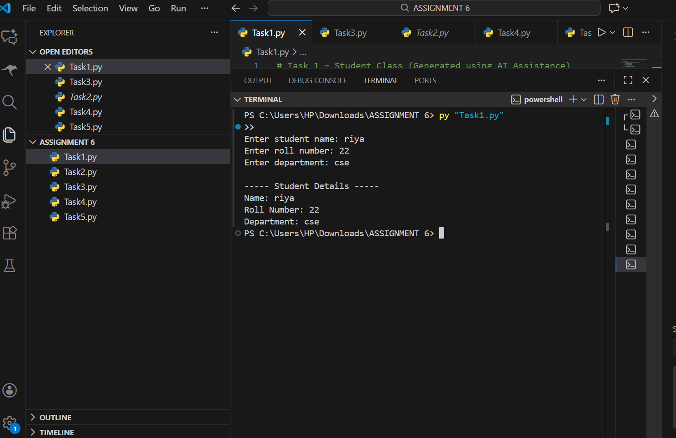

TASK 2
Explanation:
Inheritance demonstrating super().
Code:
---Code present in repo---
Output Screenshot:
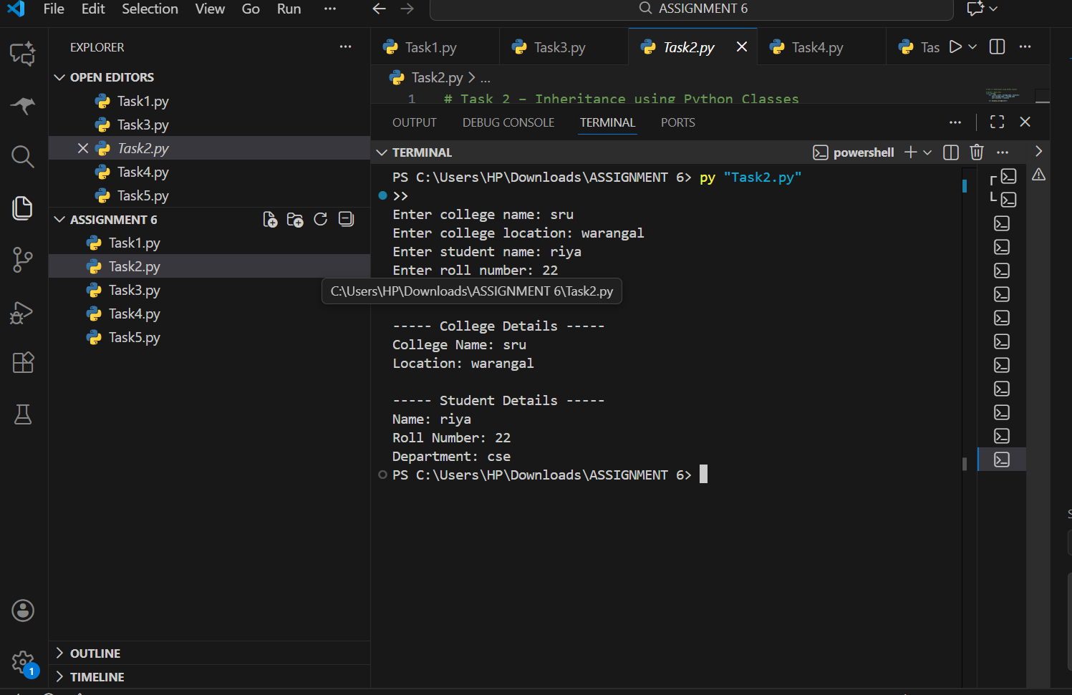

TASK 3
Explanation:
Polymorphism using animal sound classes.
Code:
---Code present in repo---
Output Screenshot:
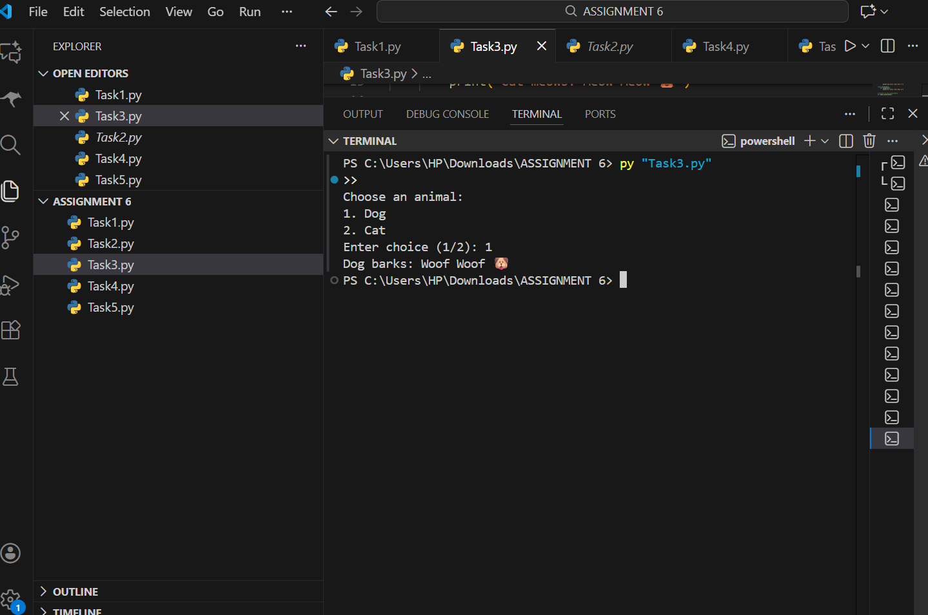

TASK 4
Explanation:
File Write & Read screenshot included.
Code:
---Code present in repo---
Output Screenshot:
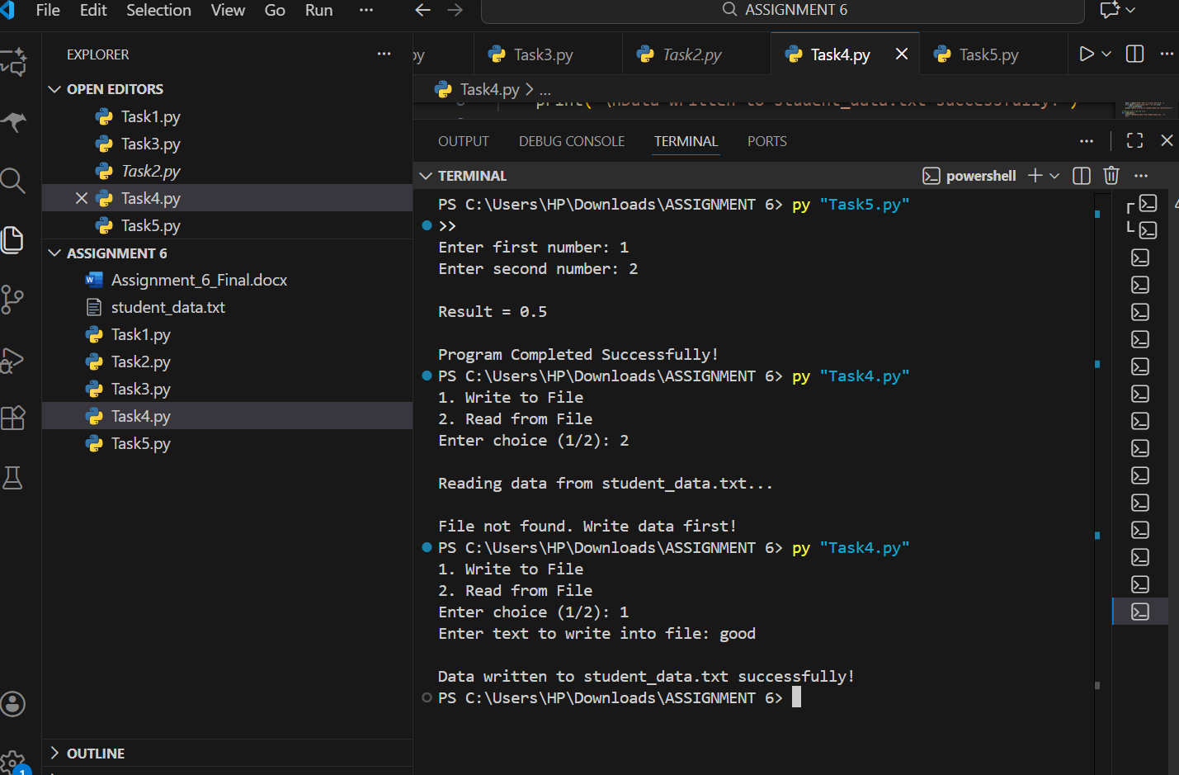

TASK 5
Explanation:
Exception Handling demonstration.
Code:
---Code present in repo---
Output Screenshot:
